**Angular Task: Evaluation Casestudy**

Task: (Topics: Basics, Components, Data Binding , Data Objects ,Angular Forms , Directives, Routing, Parameterized Routing, Services and Dependency Injection ,Pipes)

This task is an extension to the previous case study, including more functionality

1. Create the following components
   1. login
   2. home
   3. viewproducts
   4. newproduct
   5. editproduct
   6. search
2. Add the class named product with prodid ,prodname,price and category variables
3. Add a service named product and use this service for storing product information.
4. Update the service with required methods for adding , searching , deleting ,updating and showing products.
5. The login component must be loaded initially as follows.

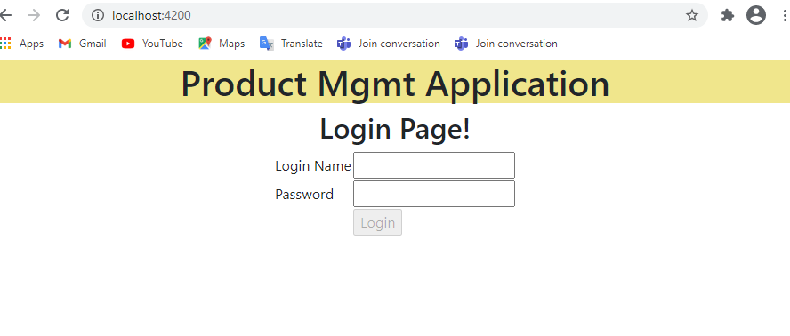

1. Login button should be enabled only if the values are entered for id and password.
2. If credentials are wrong, show error message as follows

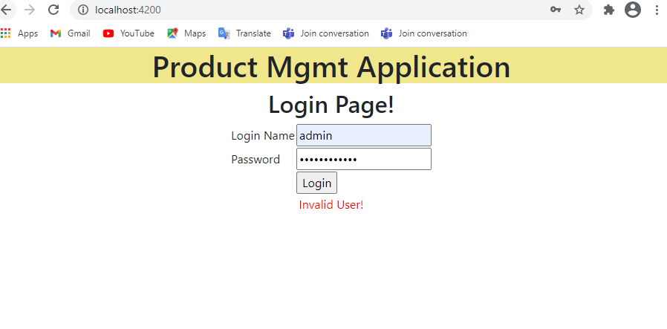

1. If credentials are “admin” and “admin@123” , redirect to home page as shown below

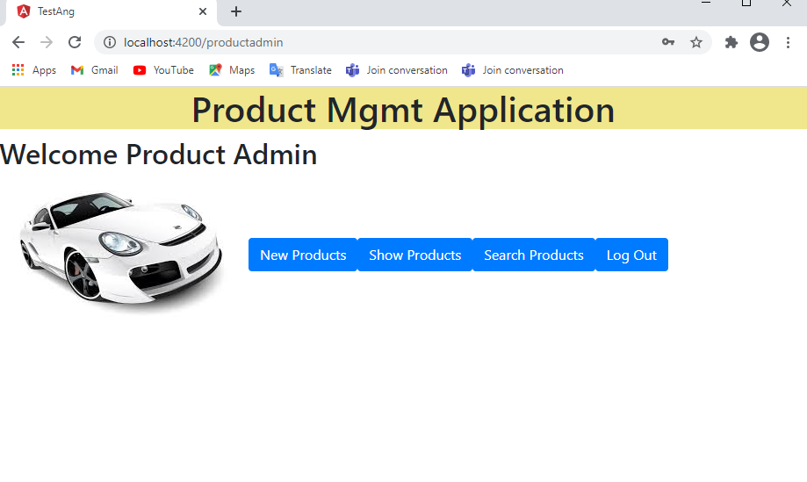

1. On click of “New Products” Button , show the product screen as follows.

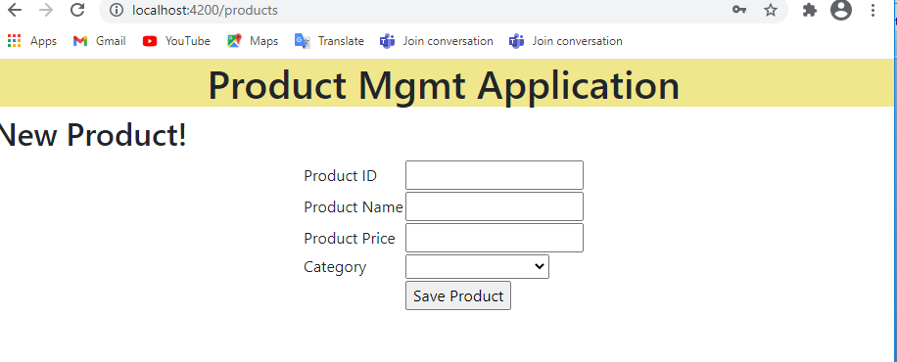

1. Add the product to the product array in service after validation when “Save Product” is clicked. And redirect to the viewproduct component and show the product list as follows.

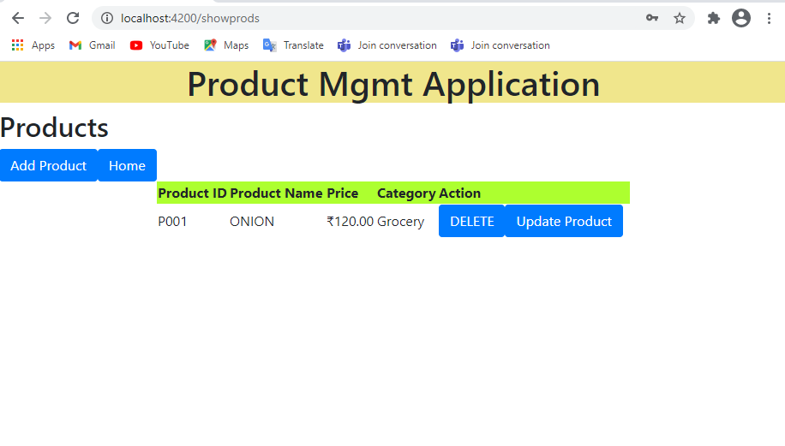

1. The name should always display in CAPS and price should display with currency symbol.
2. On click of “Delete” button , the corresponding row should be deleted.
3. On click of “Update Product”, the product details component should be loaded with data which is selected from the grid as shown.

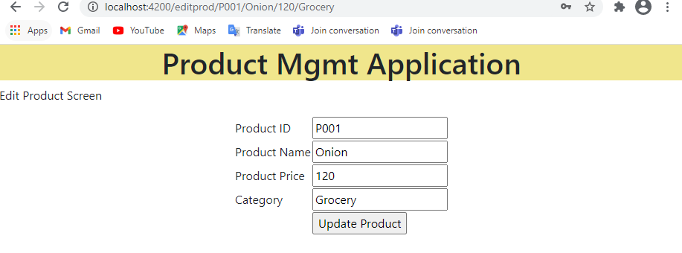

1. On click of “Update Product” , the product details should be updated and go to the view product component ,and show the updated list.
2. On click of add product button, go to newproduct page
3. On click of Home button , go to home component.
4. On click of Search Products on home, load the search component as follows.

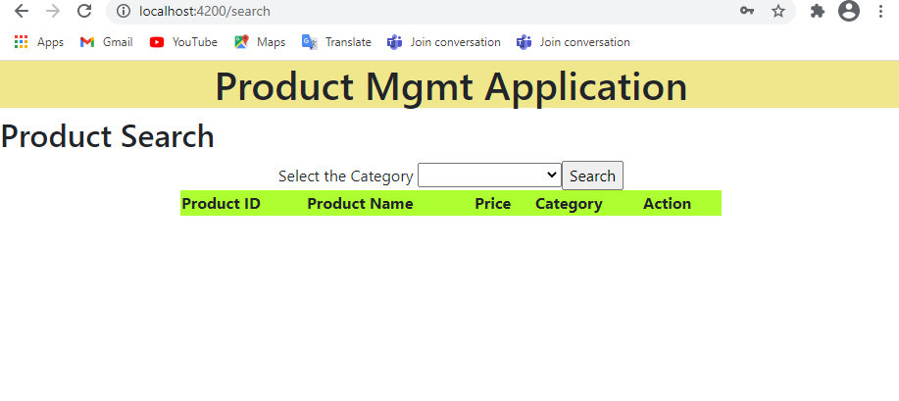

1. The categories should be pre loaded. And when clicks on Search button , display the products based on the category selected.

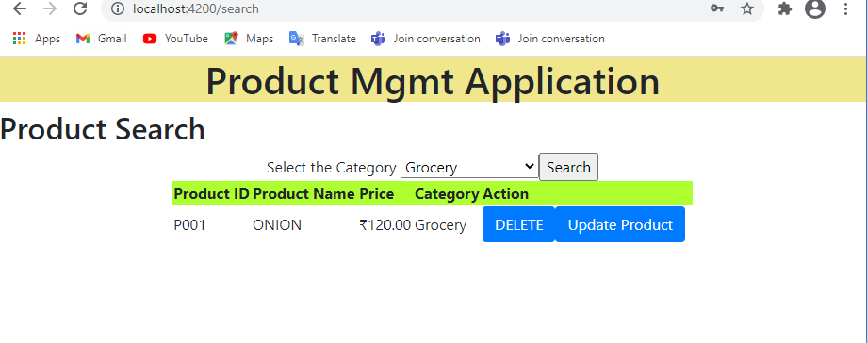

1. On LogOut , redirect to login Page.

Note : All the above requirements should be satisfied and the application should flow with proper navigation from Login to LogOut.